Network Load Balancer : 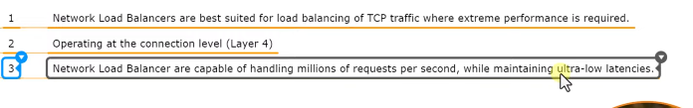
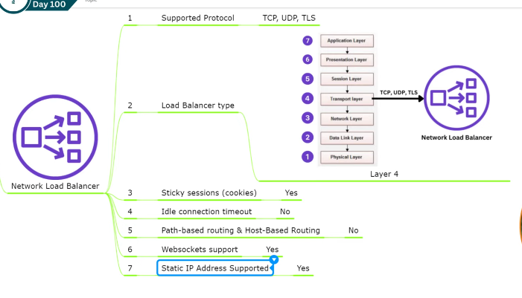
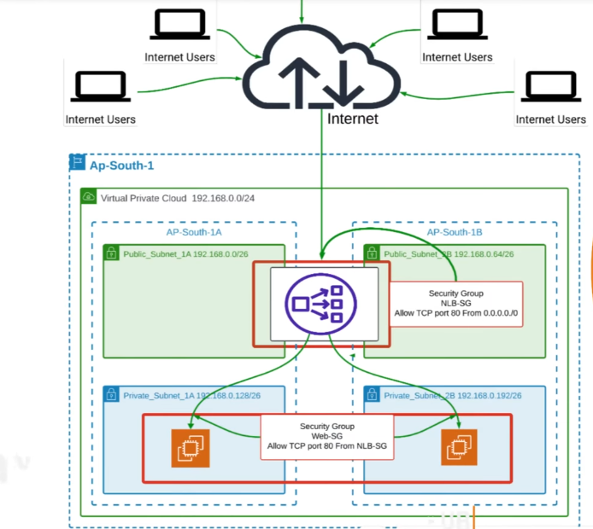
As per diagram create vpc and nlb-sg ,web-sg carefully.
Create instance as per diagram and userdata script to both server (web-server-1 and web-server-2)
#!/bin/bash
yum update –y
yum install httpd –y
systemctl start httpd
systemctl enable httpd
echo “Welcome to Web-Server-1” > /var/www/html/index.html
create Network Load-balancer
go to load balancer and create load balancer and select network load balancer
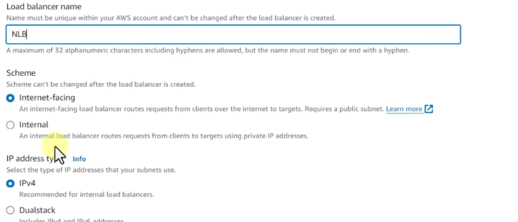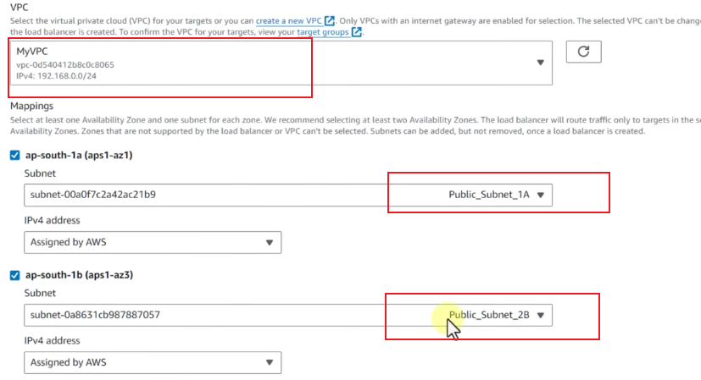
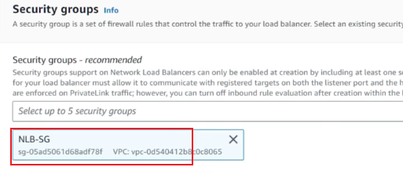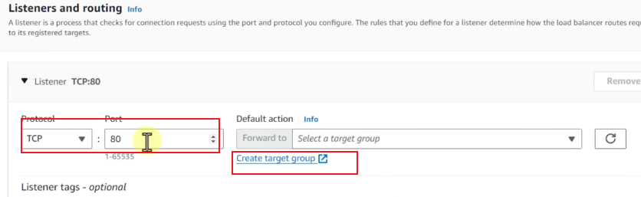
Target type : instance choose
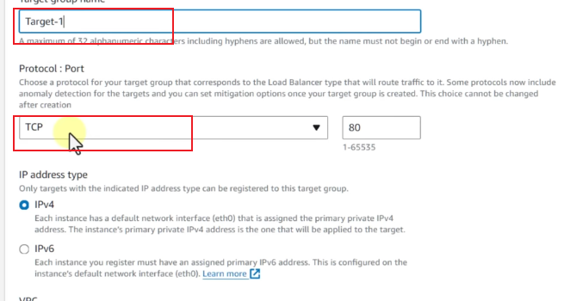
Select vpc: myvpc and health checks as it is. Click next
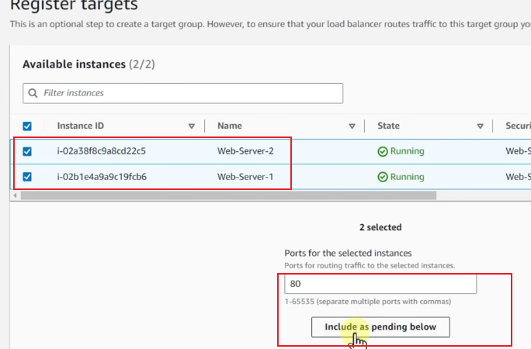click create target group
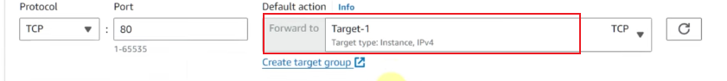create load balancer
Now test nlb dns and pasted to browser
Note: based on client’s same ip add it will divert traffic to single server unlike alb but it doesn’t mean that server 2 is not healthy.
############# Cross zone load balancer ############333
Cross-Zone Load Balancing controls whether a load balancer can send traffic to targets in all Availability Zones or only to targets in the same Availability Zone
- Cross-Zone Disabled
Each load balancer node sends traffic only to targets in its own AZ.
Internet
|
Load Balancer
/ \
AZ-a AZ-b
| |
EC2-1 EC2-3
EC2-2 EC2-4
If the LB node in AZ-a receives 100 requests:
It does not send those requests to EC2-3 or EC2-4 in AZ-b.
Advantage: Traffic stays within the AZ, which can reduce cross-AZ data transfer.
Problem: If AZ-a has fewer targets than AZ-b, its targets may receive more traffic.
- Cross-Zone Enabled
Each load balancer node can distribute traffic across targets in all enabled AZs.
Internet
|
Load Balancer
/ \
AZ-a AZ-b
| |
+----+---+----+
|
+---------+---------+
| | |
EC2-1 EC2-2 EC2-3/4

To Enable cross zone lb go to created nlb and select
